Vernacular Names: Rose Tree, Fish Poison Tree, Box Fruit | Scientific Name: Barringtonia asiatica (L.) Kurz
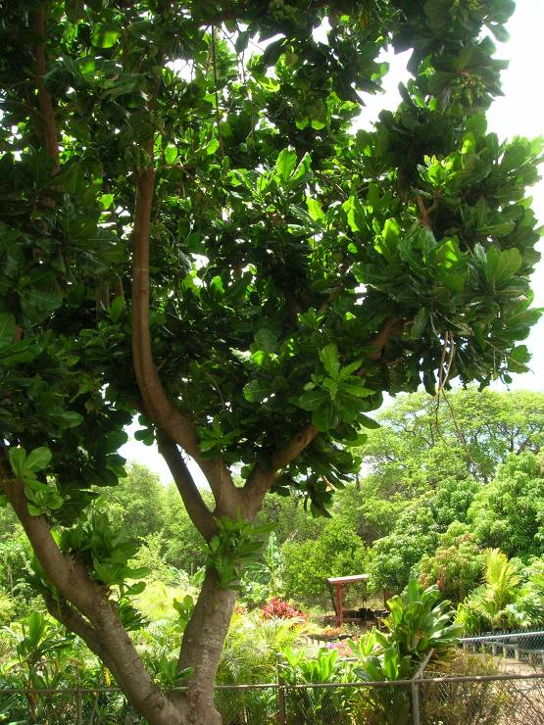 | 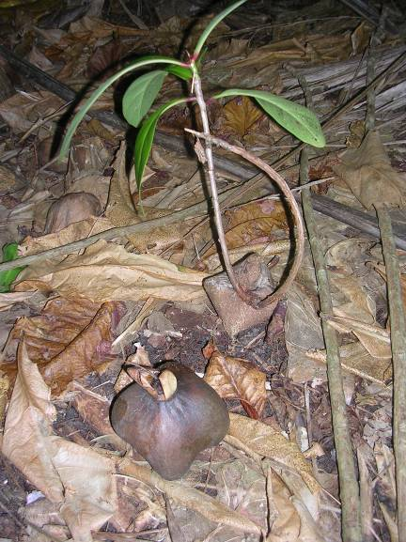  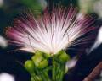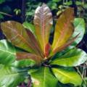
Full tree form | Germinating fruit, flower & new leaves
Native or Introduced: Native

Description: Very large tree, with large pinkish-white, pompom flowers, which last only one night before falling to the forest floor. They give off a sickly sweet smell to attract moths which pollinate the flowers at night. The fruits are a box shaped in section and float. They are initially green, but go brown after falling to the ground. The fruit persists for some time on the ground as the seedling emerges, finally rotting away. Leaves are large, have a shiny surface with prominent veins. Freshly emerged leaves have a reddish hue. This tree is unlikely to be confused with any other.

Habitat: Mostly found in previous settlement areas

Human uses: All parts of the tree are poisonous. Box fruits are potent enough to be used as a fish poison. The seeds have been used ground to a powder to stun or kill fish for easy capture, suffocating the fish and leaving the flesh unaffected.

Significance: Excellent large canopied tree; fruits easily germinate beneath the parent tree.

Propagation: Easily grown from fruit; young seedlings can be transplanted.

